Q1:-**Write function for hook to consume custom events related to Document or Window closing a Pop-up if the user clicks outside the Pop-Up.**

***Some Demo of How Look It’s & how work all Function:-***

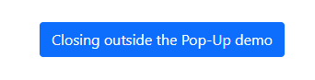

**Output:-(anywhere Click Close its)**

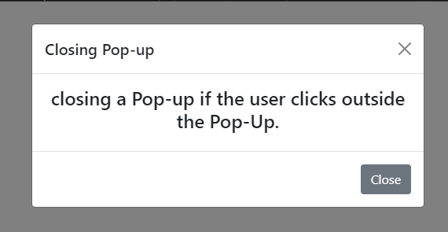

***Q2 & Q3:-***

**Write an example of Interceptor to modify HTTP requests. Ensure that each field/parameter is trimmed before request is processed.**

***Write an example to Interceptor to modify response received from any API’s before it is sent to client.***

**Code :-**

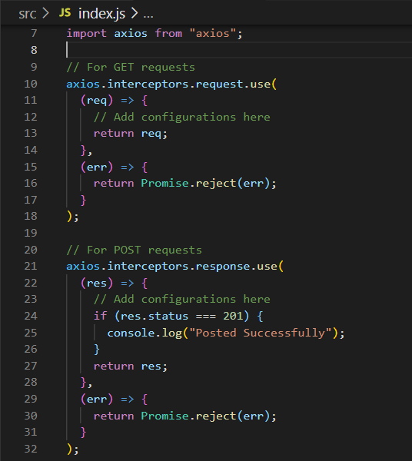

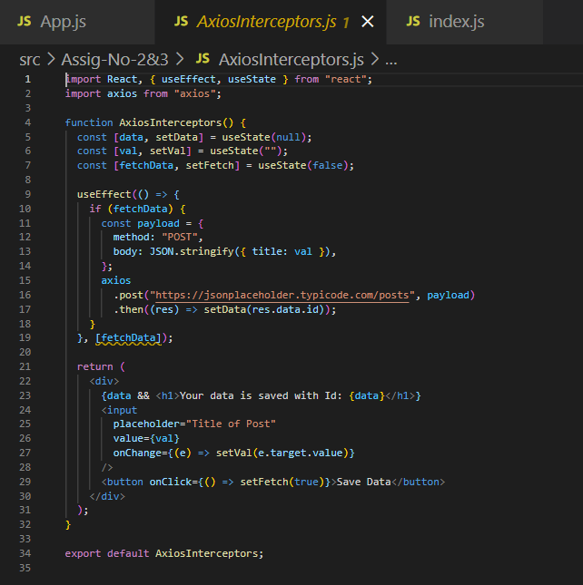

**Q4:-Write an example of custom Higher Order Component to make its children center aligned.**

Output:-

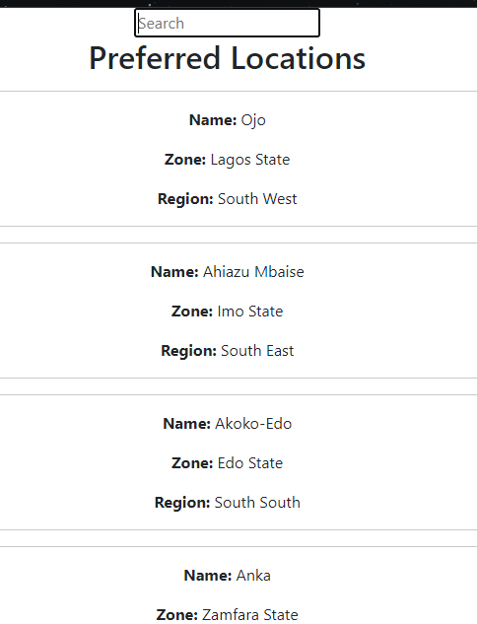

Functionality work:-

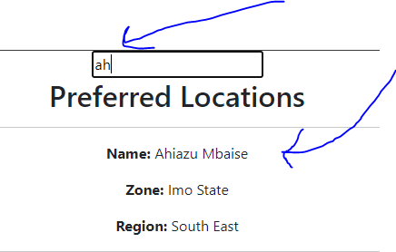

**Q5:-** **Write a custom function that lets you deep compare dependencies and then re-render if any changes are detected**.

**Sol Code:-**

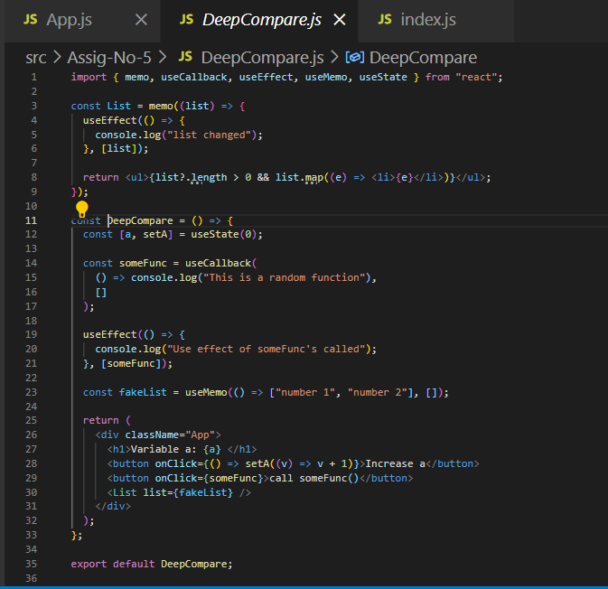

**Q6:-** **Write an example React context and provider.**

**Output:-**

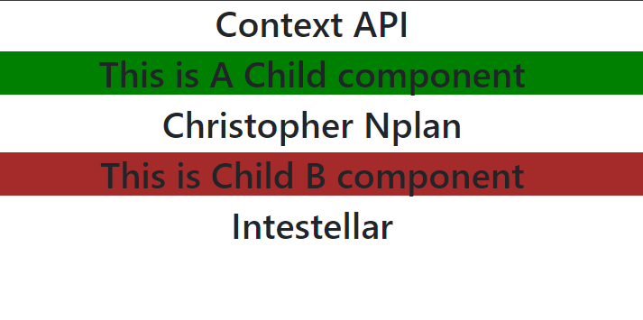

**Code:-**

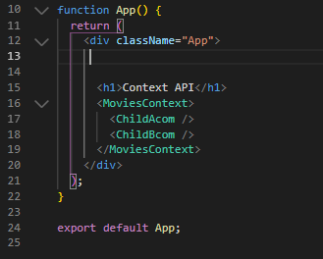

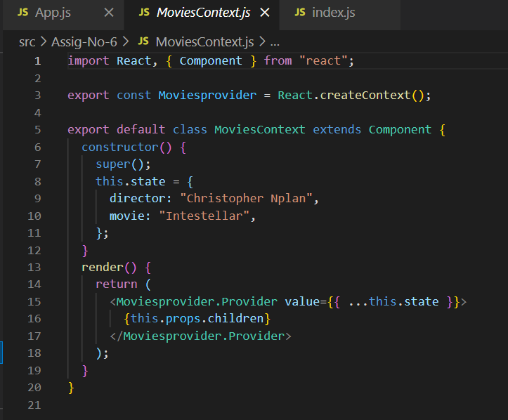

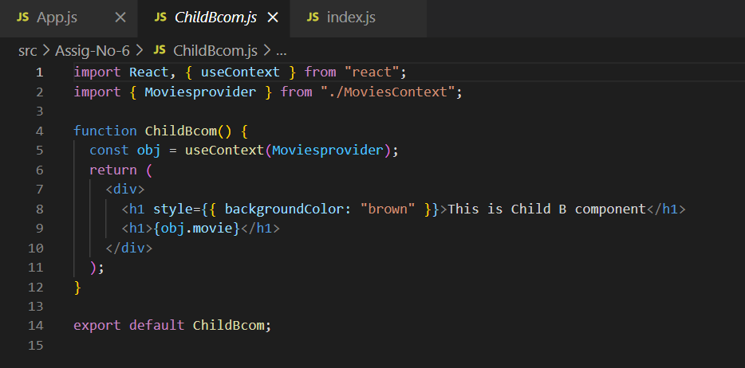

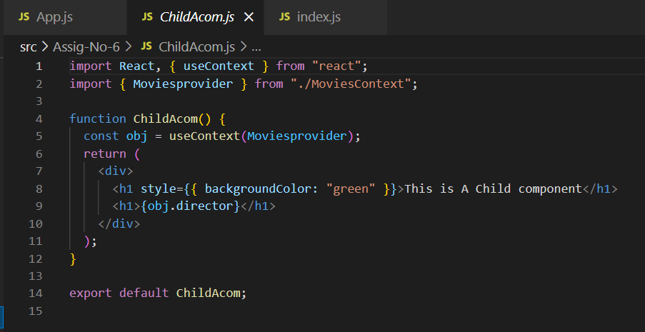

***Code of the Sol GitHub Link:-***

*https://github.com/Jeevan-kumar-Raj/Small-Tasks*

***Submitted By: - jeevan kumar***